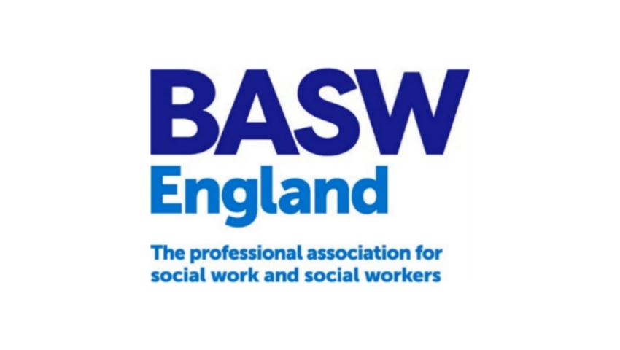

Social Work in Health
Thematic Group
Information Pack

Introduction to BASW England Thematic Groups

BASW is an independent membership organisation for social work and social work professionals. We work on behalf of our members and with the government and other stakeholders to promote best practice and support both social workers and the social work profession. Thank you for your interest in becoming a member of the Social Work in Health Thematic Group. You will find information about the group and how to apply to be a member in this information pack.

The Social Work in Health Thematic Group address issues that arise concerning social workers employed directly by the NHS or who work in roles that are embedded within services that have a predominantly health focus, that need the attention of BASW. Group members include people with lived experience of various health services where a social worker was involved e.g. hospital discharge and mental health services. See members bio document for up-to-date membership.

The Social Work in Health Thematic Group provide a focus across social work policy, practice, research, and education. A Professional Officer (BASW England team) takes responsibility, in consultation with the chairs, for agendas of meetings, recording of meetings, distribution of relevant documents.

Group Members elect their own chair and vice chair who usually serve for a period of three years. Meetings of the Group are held bi-monthly. The chairs of all the thematic groups report directly to the England Committee. The chairs of all the thematic groups meet as a group every quarter to discuss cross cutting themes, issues and work streams.

The Policy, Ethics and Human Rights Committee is a BASW UK group, charged with leading on UK policy issues and can be consulted for advice. Individual members of the UK Policy, Ethics and Human Rights group can be included in working groups of the Social Work in Health Thematic Group. The UK Policy, Ethics and Human Rights committee can also request the Thematic Groups consider certain areas/issues.

Social Work in Health Thematic Group Statement

The provision of health care in the 21st century is experiencing a rapid and continually evolving landscape, that is no longer the sole responsibility of registered health professionals. With the development of community services, roles have become diversified to include therapy staff, support workers and increasingly social workers. Registration data from 2022 suggests that approximately 48,000 of the approximately 97,000 registered social workers in England are not employed in local authorities, therefore suggesting they are employed in the NHS, private sector, charities, VCSE (voluntary, community and social enterprise) roles or working as independent or agency social workers. This figure was reached by omitting the number of local authority employed SWs from the number of registered SWs in England.

Whilst the profession is seeing a growth in the diverse roles that social workers occupy, in comparison, there has been very little research and guidance to support the recognition of the unique professional requirements of social work to succeed in a multi-disciplinary and integrated services. As such, social work in health focused organisations carries a risk of becoming a generic, one-size-fits-all profession and the skills of social workers becoming lost in a service dominated by health models of practice and medicalized treatments.

The BASW England Social Work in Health Thematic Group, evolved from the experiences of several practitioners, who raised their concerns around lack of professional supervision, limited access to Social Work specific CPD including ASYE and Practice Education; in some cases, social work leads were excluded from core networks such as Teaching Partnerships and the Principal Social Worker network. The thematic group was formed in 2022, with a remit to not only raise the profile of social work in health but advocate for a change in organisational leadership and recognition of social work skills and a change in guidance language that centers heavily on local authority social work, amongst other competing objectives.

The Social Work in Health Thematic Group has an established core group, meeting on a bi-monthly basis and providing regular open forums to support social workers in health, who may be practicing in isolated roles and have limited social work peer interaction or the opportunity for reflective supervision with another social worker. The group is looking to showcase the diversity of roles undertaken by social workers and celebrate the value they bring to the lives of the people, communities and organisations that they work with. The group works closely with other BASW thematic groups, where there are shared goals or areas of commonality.

The group has established three priorities within its current workplan and will be working with BASW and a number of other networks and organisations to address our key priorities:

- Campaign to ensure that the profession is represented by a qualified and suitably experienced registered social work profession, at senior strategic level within health organisations employing social workers.
- Campaign for future published guidance to acknowledge the significant role of social work outside of local authorities and change the language to reflect this.
- Campaign for a review of ASYE funding in adults (which disproportionally impacts on some NHS organisations, due to larger numbers of ASYE).

BASW England Organisational Structure

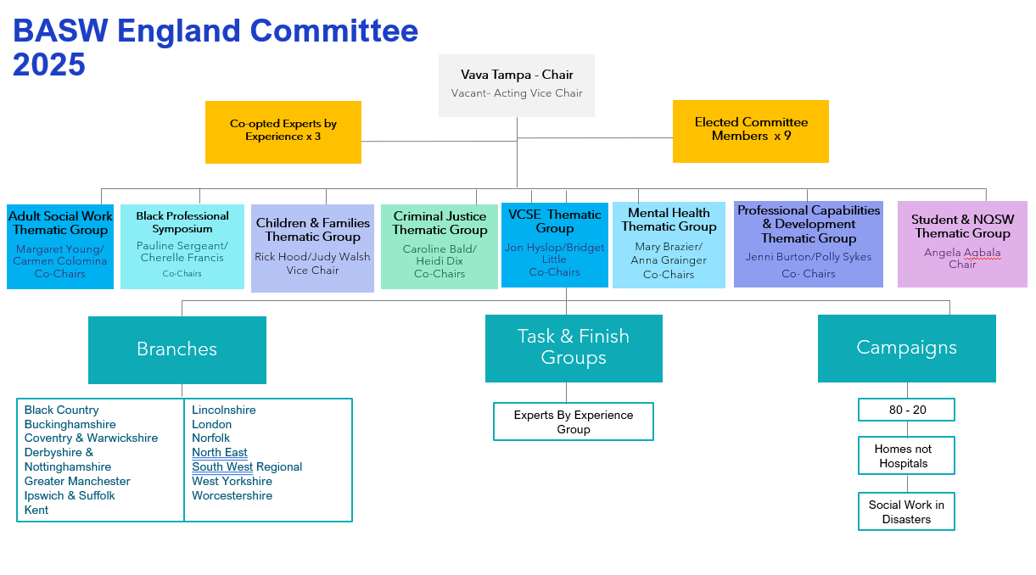

Frequently Asked Questions
What is the group for? | BASW has a network of thematic groups whose purpose is to support the England Committee by providing perspective and advice on a specialist theme to further the implementation of the BASW 2020 and 2025 Vision. The Groups are accountable and report to the England Committee, acting as a conduit between BASW and its members to:  - Inform the England Committee of views and perceptions of issues relevant to the social work specialism in line with the England Committee business plan.  - Enhance the debate on social work policy, practice, legislation, and education  - Develop statements and activity on behalf of the England Committee  We will on occasions ask members to:  - Feedback on work outside of the group meetings  - Speak on behalf of the group to the media  - Speak in their own right (re their specialism) to the media
Do I need a specific background, experience or skills? | Members do not have to have experience of committees. We need people with a range of experience and expertise of social work across policy, practice, education, and research. Members must be committed to working together to think about and debate issues.
How much time do I need to give? | Members attend bi-monthly meetings (1.5 hrs.) throughout the year. We may, additionally, ask members to review work, or comment on news items, consultations, policy, or legislative changes between meetings but this is not a requirement, however we do rely on member input to ensure our responses are reflective of current practice, so encourage you to participate when you can.
Do I need to come to London or Birmingham? | We want to encourage members from across the country. We meet online. We may hold occasional face-to-face meetings which will be hybrid events to enable full participation.
Will I receive training or support? | Each thematic group is supported by a Professional Officer (PO). The PO will work directly with members to identify any training needs and to provide support and mentoring for our members. BASW England will provide specific training and support in relation to media engagement.

Selection process

BASW actively encourages and welcomes participants from all backgrounds and especially encourages applications from marginalized communities.
We will:
- Be polite and answer any relevant questions.
- Treat your personal information confidentially.
- Make any reasonable adjustments to the selection process to enable applicants to participate equally.
- Advise you as soon as possible whether your application has been successful.
- Arrange a mutually convenient time for a discussion with the Chair and a Group member.

Making an application for membership of our Social Work in Health Thematic Group

Complete the short application form which will be provided separately. We will contact you as soon as possible to let you know whether we will be calling you for an informal discussion. We will remove contact details and membership number prior to sharing you application with the chairs, who will make the decision on whether to approve your application.

If you have questions regarding the process or anything you have read in this guide, please contact BASW England Professional Officer Denise Monks denise.monks@basw.co.uk

Chair and Vice Chair Role Description

Role Title: | Social Work in Health Thematic Group Chair and Vice Chair
Service: | BASW
Hours | - Bi-monthly meetings are 1.5 hours each  - Planning meeting prior to each thematic meeting – approx. 30 - 45 mins  - England Committee approx. 1 hour (if attending specific slot), quarterly, sign off of quarterly report for committee.  - Thematic Chairs group, meetings are 1.5 hours quarterly.  See main tasks for full details

Description of role:
- To Chair Social Work in Health group meetings in line with the agreed meeting schedule (for Vice Chairs this will be in the absence of the Co-Chair).

- Contribute ideas and lead discussion and debate on key issues for social workers in health, including policy, practice and education to develop BASW England’s position, working with the group to achieve consensus.

- Ensure the voices and views of members of the Social Work in Health Thematic Group are fed into wider internal and external conversation as well as policy and best practice development.

- Willingness to be consulted on matters relating to the varied roles of social workers in health and to offer a view based on views of members on key issues.

- Provide comments and quotes for media articles.

- Take part in meetings representing the Social Work in Health Thematic Group and BASW England.

- Lead on the development of resources and materials that support best practice in social work.

- Support and encourage growth of the Social Work in Health Thematic Group with new members from across the sector.

- Work alongside and in partnership with other members appointed as Co-Chair for the group.

- Ensure that the group acts in accordance with the Terms of Reference and BASW Code of Ethics.

- Work with BASW to develop links an alliance with other relevant organisations or grouping in order to further the aims of BASW.

- Main tasks

- Attendance at Social Work in Health Thematic Group meetings – held online bimonthly

- Planning meeting prior to each Social Work in Health Thematic Group meeting

- Rotational attendance at Thematic Group Chairs meetings- held bi-monthly – no requirement to attend each meeting.

- Rotational attendance at BASW England Committee meetings- held four times per year – no requirement to attend each meeting, shared with Chairs.

- Meetings with co-chairs and Professional Officer- as agreed

- Availability over email or telephone to respond to media requests for comments or quotes

Group Member Role Description

Role Title: | Social Work in Health Thematic Group Member
Service: | BASW
Hours | Bimonthly Meetings (1.5 hours)

Main tasks:
- Attend meetings
- Prepare for meetings by reading or accessing any materials provided.
- Contribute and participate in meetings.
- Maintain contact with the Professional Officer for the group.
- Comply with the Terms of Reference.
- Form effective working relationships with group members.

Additional tasks by agreement:
- Provide feedback on materials (verbal or written) if able to do so when asked.
- Additional roles for designated members could include:

  - providing content for media
  - being involved in other meetings and consultations

Annual renewals figures - Social Work England
https://www.skillsforcare.org.uk/Adult-Social-Care-Workforce-Data/Workforce-intelligence/documents/Social-Worker-headline-Feb2023-FINAL.pdf
Children's social work workforce, Reporting year 2022 – Explore education statistics – GOV.UK (explore-education-statistics.service.gov.uk)

